Measurement Computing 1608GX-2A0 Driver

Version 1

* 2 simple analog outputs
* 1 parameter, ANALOG_OUT_VALUE
* Use asynPortDriver C++ base class
* 131 lines of code

/* drvUSB1608G_V1.cpp

*

* Driver for Measurement Computing USB-1608G

* multi-function DAQ board using asynPortDriver base class

*

* This version implements only simple analog outputs

*

* Mark Rivers

* April 14, 2012

*/

#include <iocsh.h>

#include <epicsExport.h>

#include <asynPortDriver.h>

#include "cbw.h"

static const char *driverName = "USB1608G";

// Analog output parameters

#define analogOutValueString "ANALOG_OUT_VALUE"

#define NUM_ANALOG_OUT 2 // Number of analog outputs on 1608G

#define MAX_SIGNALS NUM_ANALOG_OUT

/** Class definition for the USB1608G class

*/

class USB1608G : public asynPortDriver {

public:

USB1608G(const char *portName, int boardNum);

/* These are the methods that we override from asynPortDriver */

virtual asynStatus writeInt32(asynUser *pasynUser, epicsInt32 value);

virtual asynStatus getBounds(asynUser *pasynUser, epicsInt32 *low,

epicsInt32 *high);

protected:

// Analog output parameters

int analogOutValue_;

#define FIRST_USB1608G_PARAM analogOutValue_

#define LAST_USB1608G_PARAM analogOutValue_

private:

int boardNum_;

};

#define NUM_PARAMS (&LAST_USB1608G_PARAM - &FIRST_USB1608G_PARAM + 1)

/** Constructor for the USB1608G class

*/

USB1608G::USB1608G(const char *portName, int boardNum)

: asynPortDriver(portName, MAX_SIGNALS, NUM_PARAMS,

asynInt32Mask | asynDrvUserMask, // Interfaces that we implement

0, // Interfaces that do callbacks

ASYN_MULTIDEVICE | ASYN_CANBLOCK, 1,

/* ASYN_CANBLOCK=1, ASYN_MULTIDEVICE=1, autoConnect=1 */

0, 0), /* Default priority and stack size */

boardNum_(boardNum)

{

// Analog output parameters

createParam(analogOutValueString, asynParamInt32, &analogOutValue_);

}

asynStatus USB1608G::getBounds(asynUser *pasynUser, epicsInt32 *low,

epicsInt32 *high)

{

int function = pasynUser->reason;

// Analog outputs are 16-bit devices

if (function == analogOutValue_) {

*low = 0;

*high = 65535;

return(asynSuccess);

} else {

return(asynError);

}

}

asynStatus USB1608G::writeInt32(asynUser *pasynUser, epicsInt32 value)

{

int addr;

int function = pasynUser->reason;

int status=0;

static const char *functionName = "writeInt32";

this->getAddress(pasynUser, &addr);

setIntegerParam(addr, function, value);

// Analog output functions

if (function == analogOutValue_) {

status = cbAOut(boardNum_, addr, BIP10VOLTS, value);

}

callParamCallbacks(addr);

if (status == 0) {

asynPrint(pasynUser, ASYN_TRACEIO_DRIVER,

"%s:%s, port %s, wrote %d to address %d\n",

driverName, functionName, this->portName, value, addr);

} else {

asynPrint(pasynUser, ASYN_TRACE_ERROR,

"%s:%s, port %s, ERROR writing %d to address %d, status=%d\n",

driverName, functionName, this->portName, value, addr, status);

}

return (status==0) ? asynSuccess : asynError;

}

/** Configuration command, called directly or from iocsh */

extern "C" int USB1608GConfig(const char *portName, int boardNum)

{

USB1608G *pUSB1608G = new USB1608G(portName, boardNum);

pUSB1608G = NULL; /* This is just to avoid compiler warnings */

return(asynSuccess);

}

static const iocshArg configArg0 = { "Port name", iocshArgString};

static const iocshArg configArg1 = { "Board number", iocshArgInt};

static const iocshArg * const configArgs[] = {&configArg0,

&configArg1};

static const iocshFuncDef configFuncDef = {"USB1608GConfig", 2, configArgs};

static void configCallFunc(const iocshArgBuf *args)

{

USB1608GConfig(args[0].sval, args[1].ival);

}

void drvUSB1608GRegister(void)

{

iocshRegister(&configFuncDef,configCallFunc);

}

extern "C" {

epicsExportRegistrar(drvUSB1608GRegister);

}

**measCompAnalogOut.template**

**record(ao,"$(P)$(R)") {**

**field(PINI, "YES")**

**field(DTYP, "asynInt32")**

**field(FLNK, "$(P)$(R)Return.PROC PP MS")**

**field(OUT, "@asyn($(PORT),$(ADDR))ANALOG_OUT_VALUE")**

**field(EGUL, "$(EGUL)")**

**field(DRVL, "$(DRVL)")**

**field(LOPR, "$(LOPR)")**

**field(EGUF, "$(EGUF)")**

**field(DRVH, "$(DRVH)")**

**field(HOPR, "$(HOPR)")**

**field(PREC, "$(PREC)")**

**field(LINR, "LINEAR")**

**field(VAL, "$(VAL)")**

**}**

**record(ao,"$(P)$(R)Return") {**

**field(DTYP, "asynInt32")**

**field(DISV, "0")**

**field(SDIS, "$(P)$(R)Pulse.VAL NPP NMS")**

**field(OUT, "@asyn($(PORT),$(ADDR))ANALOG_OUT_VALUE")**

**field(OMSL, "closed_loop")**

**field(EGUL, "$(EGUL)")**

**field(DRVL, "$(DRVL)")**

**field(LOPR, "$(LOPR)")**

**field(EGUF, "$(EGUF)")**

**field(DRVH, "$(DRVH)")**

**field(HOPR, "$(HOPR)")**

**field(PREC, "$(PREC)")**

**field(LINR, "LINEAR")**

**field(VAL, "$(VAL)")**

**}**

**record(bo,"$(P)$(R)Pulse") {**

**field(ZNAM, "Normal")**

**field(ONAM, "Pulse")**

**}**

**record(ao,"$(P)$(R)TweakVal") {**

**field(PREC, "$(PREC)")**

**}**

**record(calcout,"$(P)$(R)TweakUp") {**

**field(CALC, "A+B")**

**field(INPA, "$(P)$(R).VAL NPP MS")**

**field(INPB, "$(P)$(R)TweakVal.VAL NPP MS")**

**field(OUT, "$(P)$(R).VAL PP MS")**

**field(PREC, "$(PREC)")**

**}**

**record(calcout,"$(P)$(R)TweakDown") {**

**field(CALC, "A-B")**

**field(INPA, "$(P)$(R).VAL NPP MS")**

**field(INPB, "$(P)$(R)TweakVal.VAL NPP MS")**

**field(OUT, "$(P)$(R).VAL PP MS")**

**field(PREC, "$(PREC)")**

**}**

**st.cmd_V1**

**< envPaths**

**## Register all support components**

**dbLoadDatabase "../../dbd/measCompApp.dbd"**

**measCompApp_registerRecordDeviceDriver pdbbase**

**dbLoadTemplate("1608G.substitutions_V1")**

**## Configure port driver**

**# USB1608GConfig(**

**# portName, # The name to give to this asyn port driver**

**# boardNum) # The number of this board assigned by the**

**# Measurement Computing Instacal program**

**USB1608GConfig("1608G_1", 1)**

**#asynSetTraceMask 1608G_1 -1 255**

**iocInit**

**1608G.substitutions_V1**

**# asyn record**

**file "$(ASYN)/db/asynRecord.db"**

**{**

**pattern**

**{ P, R, PORT, ADDR, IMAX, OMAX}**

**{ 1608G:, asyn1, 1608G_1, 0, 80, 80}**

**}**

**# Analog outputs**

**file "$(MEASCOMP)/measCompApp/Db/measCompAnalogOut.template"**

**{**

**pattern**

**{ P, R, VAL, PORT, ADDR, EGUL, DRVL, LOPR, EGUF, DRVH, HOPR, PREC}**

**{ 1608G:, Ao1, 0, 1608G_1, 0, -10., -10., -10., 10., 10., 10., 4}**

**{ 1608G:, Ao2, 0, 1608G_1, 1, -10., -10., -10., 10., 10., 10., 4}**

**}**

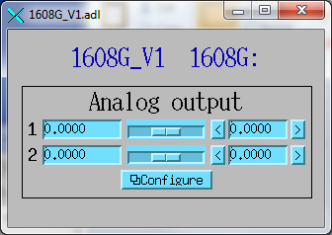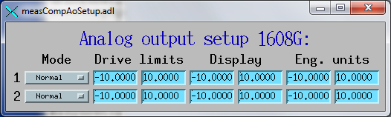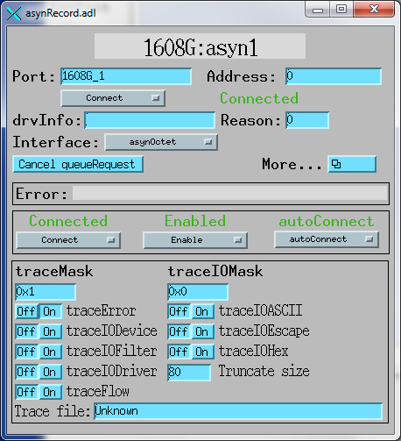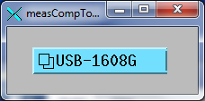

Measurement Computing 1608GX-2A0 Driver

Version 2

* Add 8 simple analog inputs
  + 2 new parameters, ANALOG_IN_VALUE, ANALOG_IN_RANGE
* Add report() function
* 197 lines of code (~60 more than V1)

/* drvUSB1608G_V2.cpp

*

* Driver for Measurement Computing USB-1608G multi-function DAQ board using asynPortDriver base class

*

**\* This version implements simple analog inputs and simple analog outputs**

*

* Mark Rivers

* April 14, 2012

*/

#include <iocsh.h>

#include <epicsExport.h>

#include <asynPortDriver.h>

#include "cbw.h"

static const char *driverName = "USB1608G";

// Analog output parameters

#define analogOutValueString "ANALOG_OUT_VALUE"

**// Analog input parameters**

**#define analogInValueString "ANALOG_IN_VALUE"**

**#define analogInRangeString "ANALOG_IN_RANGE"**

**#define NUM_ANALOG_IN 16 // Number analog inputs on 1608G**

#define NUM_ANALOG_OUT 2 // Number of analog outputs on 1608G

**#define MAX_SIGNALS NUM_ANALOG_IN**

/** Class definition for the USB1608G class

*/

class USB1608G : public asynPortDriver {

public:

USB1608G(const char *portName, int boardNum);

/* These are the methods that we override from asynPortDriver */

virtual asynStatus writeInt32(asynUser *pasynUser, epicsInt32 value);

**virtual asynStatus readInt32(asynUser *pasynUser, epicsInt32 *value);**

virtual asynStatus getBounds(asynUser *pasynUser, epicsInt32 *low,

epicsInt32 *high);

**virtual void report(FILE *fp, int details);**

protected:

// Analog output parameters

int analogOutValue_;

#define FIRST_USB1608G_PARAM analogOutValue_

**// Analog input parameters**

**int analogInValue_;**

**int analogInRange_;**

**#define LAST_USB1608G_PARAM analogInRange_**

private:

int boardNum_;

};

#define NUM_PARAMS (&LAST_USB1608G_PARAM - &FIRST_USB1608G_PARAM + 1)

/** Constructor for the USB1608G class

*/

USB1608G::USB1608G(const char *portName, int boardNum)

: asynPortDriver(portName, MAX_SIGNALS, NUM_PARAMS,

asynInt32Mask | asynDrvUserMask, // Interfaces that we implement

0, // Interfaces that do callbacks

ASYN_MULTIDEVICE | ASYN_CANBLOCK, 1,

/* ASYN_CANBLOCK=1, ASYN_MULTIDEVICE=1, autoConnect=1 */

0, 0), /* Default priority and stack size */

boardNum_(boardNum)

{

// Analog output parameters

createParam(analogOutValueString, asynParamInt32, &analogOutValue_);

**// Analog input parameters**

**createParam(analogInValueString, asynParamInt32, &analogInValue_);**

**createParam(analogInRangeString, asynParamInt32, &analogInRange_);**

}

asynStatus USB1608G::getBounds(asynUser *pasynUser, epicsInt32 *low,

epicsInt32 *high)

{

int function = pasynUser->reason;

**// Both the analog outputs and analog inputs are 16-bit devices**

**if ((function == analogOutValue_) ||**

**(function == analogInValue_)) {**

*low = 0;

*high = 65535;

return(asynSuccess);

} else {

return(asynError);

}

}

**NOTE: No change, we don’t handle analogOutRange_ here,**

**just put in parameter library**

asynStatus USB1608G::writeInt32(asynUser *pasynUser, epicsInt32 value)

{

int addr;

int function = pasynUser->reason;

int status=0;

static const char *functionName = "writeInt32";

this->getAddress(pasynUser, &addr);

setIntegerParam(addr, function, value);

// Analog output functions

if (function == analogOutValue_) {

status = cbAOut(boardNum_, addr, BIP10VOLTS, value);

}

callParamCallbacks(addr);

if (status == 0) {

asynPrint(pasynUser, ASYN_TRACEIO_DRIVER,

"%s:%s, port %s, wrote %d to address %d\n",

driverName, functionName, this->portName, value, addr);

} else {

asynPrint(pasynUser, ASYN_TRACE_ERROR,

"%s:%s, port %s, ERROR writing %d to address %d, status=%d\n",

driverName, functionName, this->portName, value, addr, status);

}

return (status==0) ? asynSuccess : asynError;

}

**asynStatus USB1608G::readInt32(asynUser *pasynUser, epicsInt32 *value)**

**{**

**int addr;**

**int function = pasynUser->reason;**

**int status=0;**

**unsigned short shortVal;**

**int range;**

**//static const char *functionName = "readInt32";**

**this->getAddress(pasynUser, &addr);**

**// Analog input function**

**if (function == analogInValue_) {**

**getIntegerParam(addr, analogInRange_, &range);**

**status = cbAIn(boardNum_, addr, range, &shortVal);**

**\*value = shortVal;**

**setIntegerParam(addr, analogInValue_, *value);**

**}**

**// Other functions we call the base class method**

**else {**

**status = asynPortDriver::readInt32(pasynUser, value);**

**}**

**callParamCallbacks(addr);**

**return (status==0) ? asynSuccess : asynError;**

**}**

**/* Report parameters */**

**void USB1608G::report(FILE *fp, int details)**

**{**

**int i;**

**int range;**

**fprintf(fp, " Port: %s, board number=%d\n",**

**this->portName, boardNum_);**

**if (details >= 1) {**

**for (i=0; i<NUM_ANALOG_IN; i++) {**

**getIntegerParam(i, analogInRange_, &range);**

**fprintf(fp, "channel %d range=%d", i, range);**

**}**

**fprintf(fp, "\n");**

**}**

**asynPortDriver::report(fp, details);**

**}**

**measCompAnalogIn.template**

**record(ai,"$(P)$(R)")**

**{**

**field(SCAN, "$(SCAN)")**

**field(DTYP, "asynInt32")**

**field(INP, "@asyn($(PORT),$(ADDR))ANALOG_IN_VALUE")**

**field(LINR, "LINEAR")**

**field(EGUF, "$(EGUF)")**

**field(EGUL, "$(EGUL)")**

**field(HOPR, "$(HOPR)")**

**field(LOPR, "$(LOPR)")**

**field(PREC, "$(PREC)")**

**}**

**# Note: the ZRVL, etc. fields correspond to the values of BIP1VOLTS, etc. in cbw.h**

**record(mbbo,"$(P)$(R)Range")**

**{**

**field(PINI, "YES")**

**field(DTYP, "asynInt32")**

**field(OUT, "@asyn($(PORT),$(ADDR))ANALOG_IN_RANGE")**

**field(ZRST, "+-1V")**

**field(ZRVL, "4")**

**field(ONST, "+-2V")**

**field(ONVL, "14")**

**field(TWST, "+-5V")**

**field(TWVL, "0")**

**field(THST, "+-10V")**

**field(THVL, "1")**

**field(VAL, "$(RANGE)")**

**}**

**1608G.substitutions_V2**

**# Analog inputs**

**file "$(MEASCOMP)/measCompApp/Db/measCompAnalogIn.template"**

**{**

**pattern**

**{ P, R, PORT, ADDR, EGUL, LOPR, EGUF, HOPR, RANGE, SCAN, PREC}**

**{ 1608G:, Ai1, 1608G_1, 0, -10., -10., 10., 10., 3, "1 second", 4}**

**{ 1608G:, Ai2, 1608G_1, 1, -10., -10., 10., 10., 3, "1 second", 4}**

**{ 1608G:, Ai3, 1608G_1, 2, -5., -5., 5., 5., 2, "1 second", 4}**

**{ 1608G:, Ai4, 1608G_1, 3, -5., -5., 5., 5., 2, "1 second", 4}**

**{ 1608G:, Ai5, 1608G_1, 4, -2., -2., 2., 2., 1, "1 second", 4}**

**{ 1608G:, Ai6, 1608G_1, 5, -2., -2., 2., 2., 1, "1 second", 4}**

**{ 1608G:, Ai7, 1608G_1, 6, -1., -1., 1., 1., 0, "1 second", 4}**

**{ 1608G:, Ai8, 1608G_1, 7, -1., -1., 1., 1., 0, "1 second", 4}**

**}**

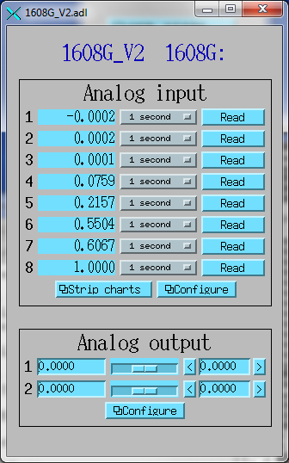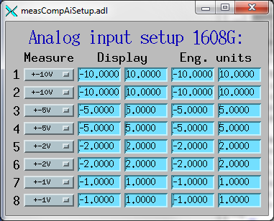

Measurement Computing 1608GX-2A0 Driver

Version 3

* Add digital outputs
  + 2 new parameters, DIGITAL_DIRECTION, DIGITAL_OUTPUT
* 253 lines of code (~60 more than Version 2)

/* drvUSB1608G_V3.cpp

*

* This version implements digital outputs, simple analog inputs and simple analog outputs

*

* Mark Rivers

* April 14, 2012

*/

#include <iocsh.h>

#include <epicsExport.h>

#include <asynPortDriver.h>

#include "cbw.h"

static const char *driverName = "USB1608G";

// Analog output parameters

#define analogOutValueString "ANALOG_OUT_VALUE"

// Analog input parameters

#define analogInValueString "ANALOG_IN_VALUE"

#define analogInRangeString "ANALOG_IN_RANGE"

**// Digital I/O parameters**

**#define digitalDirectionString "DIGITAL_DIRECTION"**

**#define digitalOutputString "DIGITAL_OUTPUT"**

#define NUM_ANALOG_IN 16 // Number analog inputs on 1608G

#define NUM_ANALOG_OUT 2 // Number of analog outputs on 1608G

**#define NUM_IO_BITS 8 // Number of digital I/O bits on 1608G**

#define MAX_SIGNALS NUM_ANALOG_IN

/** Class definition for the USB1608G class

*/

class USB1608G : public asynPortDriver {

public:

USB1608G(const char *portName, int boardNum);

/* These are the methods that we override from asynPortDriver */

virtual asynStatus writeInt32(asynUser *pasynUser, epicsInt32 value);

virtual asynStatus readInt32(asynUser *pasynUser, epicsInt32 *value);

virtual asynStatus getBounds(asynUser *pasynUser, epicsInt32 *low,

epicsInt32 *high);

**virtual asynStatus writeUInt32Digital(asynUser *pasynUser, epicsUInt32 value,**

**epicsUInt32 mask);**

virtual void report(FILE *fp, int details);

protected:

// Analog output parameters

int analogOutValue_;

#define FIRST_USB1608G_PARAM analogOutValue_

// Analog input parameters

int analogInValue_;

int analogInRange_;

**// Digital I/O parameters**

**int digitalDirection_;**

**int digitalOutput_;**

#define LAST_USB1608G_PARAM digitalOutput_

private:

int boardNum_;

};

/** Constructor for the USB1608G class

*/

USB1608G::USB1608G(const char *portName, int boardNum)

: asynPortDriver(portName, MAX_SIGNALS, NUM_PARAMS,

// Interfaces that we implement

asynInt32Mask | **asynUInt32DigitalMask** | asynDrvUserMask,

**// Interfaces that do callbacks**

**asynUInt32DigitalMask,**

ASYN_MULTIDEVICE | ASYN_CANBLOCK, 1,

/* ASYN_CANBLOCK=1, ASYN_MULTIDEVICE=1, autoConnect=1 */

0, 0), /* Default priority and stack size */

boardNum_(boardNum)

{

// Analog output parameters

createParam(analogOutValueString, asynParamInt32, &analogOutValue_);

// Analog input parameters

createParam(analogInValueString, asynParamInt32, &analogInValue_);

createParam(analogInRangeString, asynParamInt32, &analogInRange_);

**// Digital I/O parameters**

**createParam(digitalDirectionString, asynParamUInt32Digital, &digitalDirection_);**

**createParam(digitalOutputString, asynParamUInt32Digital, &digitalOutput_);**

}

**asynStatus USB1608G::writeUInt32Digital(asynUser *pasynUser, epicsUInt32 value, epicsUInt32 mask)**

**{**

**int function = pasynUser->reason;**

**int status=0;**

**int i;**

**epicsUInt32 outValue=0, outMask, direction=0;**

**static const char *functionName = "writeUInt32Digital";**

**setUIntDigitalParam(function, value, mask);**

**if (function == digitalDirection_) {**

**outValue = (value == 0) ? DIGITALIN : DIGITALOUT;**

**for (i=0; i<NUM_IO_BITS; i++) {**

**if ((mask & (1<<i)) != 0) {**

**status = cbDConfigBit(boardNum_, AUXPORT, i, outValue);**

**}**

**}**

**}**

**else if (function == digitalOutput_) {**

**getUIntDigitalParam(digitalDirection_, &direction, 0xFFFFFFFF);**

**for (i=0, outMask=1; i<NUM_IO_BITS; i++, outMask = (outMask<<1)) {**

**// Only write the value if the mask has this bit set and the direction**

**// for that bit is output (1)**

**outValue = ((value &outMask) == 0) ? 0 : 1;**

**if ((mask & outMask & direction) != 0) {**

**status = cbDBitOut(boardNum_, AUXPORT, i, outValue);**

**}**

**}**

**}**

**callParamCallbacks();**

**if (status == 0) {**

**asynPrint(pasynUser, ASYN_TRACEIO_DRIVER,**

**"%s:%s, port %s, wrote outValue=0x%x, value=0x%x, mask=0x%x, direction=0x%x\n",**

**driverName, functionName, this->portName, outValue, value, mask, direction);**

**} else {**

**asynPrint(pasynUser, ASYN_TRACE_ERROR,**

**"%s:%s, port %s, ERROR writing outValue=0x%x, value=0x%x, mask=0x%x,**

**direction=0x%x, status=%d\n",**

**driverName, functionName, this->portName, outValue, value, mask, direction,**

**status);**

**}**

**return (status==0) ? asynSuccess : asynError;**

**}**

**measCompBinaryDir.template**

**record(bo, "$(P)$(R)")**

**{**

**field(PINI, "YES")**

**field(DTYP, "asynUInt32Digital")**

**field(OUT, "@asynMask($(PORT),$(ADDR),$(MASK))DIGITAL_DIRECTION")**

**field(ZNAM, "In")**

**field(ONAM, "Out")**

**field(VAL, "$(VAL)")**

**field(PINI, "YES")**

**}**

**measCompBinaryOut.template**

**record(bo, "$(P)$(R)")**

**{**

**field(PINI, "YES")**

**field(DTYP, "asynUInt32Digital")**

**field(OUT, "@asynMask($(PORT),$(ADDR),$(MASK))DIGITAL_OUTPUT")**

**field(ZNAM, "Low")**

**field(ONAM, "High")**

**}**

**# This is a readback of the output, with SCAN=I/O Intr**

**record(bi, "$(P)$(R)_RBV")**

**{**

**field(DTYP, "asynUInt32Digital")**

**field(INP, "@asynMask($(PORT),$(ADDR),$(MASK))DIGITAL_OUTPUT")**

**field(ZNAM, "Low")**

**field(ONAM, "High")**

**field(SCAN, "I/O Intr")**

**}**

**measCompLongOut.template**

**record(longout, "$(P)$(R)")**

**{**

**field(PINI, "YES")**

**field(DTYP, "asynUInt32Digital")**

**field(OUT, "@asynMask($(PORT),$(ADDR),$(MASK))DIGITAL_OUTPUT")**

**}**

**# This is a readback of the output, with SCAN=I/O Intr**

**record(longin, "$(P)$(R)_RBV")**

**{**

**field(DTYP, "asynUInt32Digital")**

**field(INP, "@asynMask($(PORT),$(ADDR),$(MASK))DIGITAL_OUTPUT")**

**field(SCAN, "I/O Intr")**

**}**

**1608G.substitutions_V3**

**file "$(MEASCOMP)/measCompApp/Db/measCompLongOut.template"**

**{**

**pattern**

**{ P, R, MASK, PORT, ADDR}**

**{ 1608G:, Lo, 0xFF, 1608G_1, 0}**

**}**

**file "$(MEASCOMP)/measCompApp/Db/measCompBinaryOut.template"**

**{**

**pattern**

**{ P, R, MASK, PORT, ADDR}**

**{ 1608G:, Bo1, 0x01 1608G_1, 0}**

**{ 1608G:, Bo2, 0x02 1608G_1, 0}**

**{ 1608G:, Bo3, 0x04 1608G_1, 0}**

**{ 1608G:, Bo4, 0x08 1608G_1, 0}**

**{ 1608G:, Bo5, 0x10 1608G_1, 0}**

**{ 1608G:, Bo6, 0x20 1608G_1, 0}**

**{ 1608G:, Bo7, 0x40 1608G_1, 0}**

**{ 1608G:, Bo8, 0x80 1608G_1, 0}**

**}**

**# Direction bits on binary I/O**

**# VAL 0=input, 1=output**

**file "$(MEASCOMP)/measCompApp/Db/measCompBinaryDir.template"**

**{**

**pattern**

**{ P, R, MASK, VAL, PORT, ADDR}**

**{ 1608G:, Bd1, 0x01 0, 1608G_1, 0}**

**{ 1608G:, Bd2, 0x02 0, 1608G_1, 0}**

**{ 1608G:, Bd3, 0x04 0, 1608G_1, 0}**

**{ 1608G:, Bd4, 0x08 0, 1608G_1, 0}**

**{ 1608G:, Bd5, 0x10 1, 1608G_1, 0}**

**{ 1608G:, Bd6, 0x20 1, 1608G_1, 0}**

**{ 1608G:, Bd7, 0x40 1, 1608G_1, 0}**

**{ 1608G:, Bd8, 0x80 1, 1608G_1, 0}**

**}**

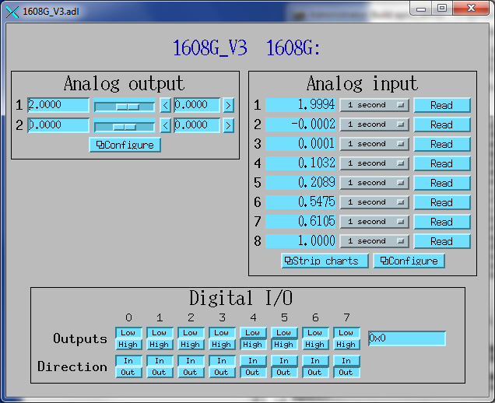

Measurement Computing 1608GX-2A0 Driver

Version 4

* Add digital inputs
  + 1 new parameter, DIGITAL_INPUT
* Add a poller thread to read digital inputs; their records are SCAN=I/O Intr
* 314 lines of code (~60 more than Version 3)

/* drvUSB1608G_V2.cpp

* This version implements digital **inputs and** outputs, simple analog inputs and simple analog outputs, with a poller thread

*

* Mark Rivers

* April 14, 2012

*/

#include <iocsh.h>

#include <epicsExport.h>

#include <epicsThread.h>

#include <asynPortDriver.h>

#include "cbw.h"

static const char *driverName = "USB1608G";

// Analog output parameters

#define analogOutValueString "ANALOG_OUT_VALUE"

// Analog input parameters

#define analogInValueString "ANALOG_IN_VALUE"

#define analogInRangeString "ANALOG_IN_RANGE"

// Digital I/O parameters

#define digitalDirectionString "DIGITAL_DIRECTION"

**#define digitalInputString "DIGITAL_INPUT"**

#define digitalOutputString "DIGITAL_OUTPUT"

#define NUM_ANALOG_IN 16 // Number analog inputs on 1608G

#define NUM_ANALOG_OUT 2 // Number of analog outputs on 1608G

#define NUM_IO_BITS 8 // Number of digital I/O bits on 1608G

#define MAX_SIGNALS NUM_ANALOG_IN

**#define DEFAULT_POLL_TIME 0.01**

/** Class definition for the USB1608G class

*/

class USB1608G : public asynPortDriver {

public:

USB1608G(const char *portName, int boardNum);

/* These are the methods that we override from asynPortDriver */

virtual asynStatus writeInt32(asynUser *pasynUser, epicsInt32 value);

virtual asynStatus readInt32(asynUser *pasynUser, epicsInt32 *value);

virtual asynStatus getBounds(asynUser *pasynUser, epicsInt32 *low,

epicsInt32 *high);

virtual asynStatus writeUInt32Digital(asynUser *pasynUser, epicsUInt32 value,

epicsUInt32 mask);

virtual void report(FILE *fp, int details);

**// These should be private but are called from C**

**virtual void pollerThread(void);**

protected:

// Analog output parameters

int analogOutValue_;

#define FIRST_USB1608G_PARAM analogOutValue_

// Analog input parameters

int analogInValue_;

int analogInRange_;

// Digital I/O parameters

int digitalDirection_;

**int digitalInput_;**

int digitalOutput_;

#define LAST_USB1608G_PARAM digitalOutput_

private:

int boardNum_;

**double pollTime_;**

**int forceCallback_;**

};

#define NUM_PARAMS (&LAST_USB1608G_PARAM - &FIRST_USB1608G_PARAM + 1)

**static void pollerThreadC(void * pPvt)**

**{**

**USB1608G *pUSB1608G = (USB1608G *)pPvt;**

**pUSB1608G->pollerThread();**

**}**

/** Constructor for the USB1608G class */

USB1608G::USB1608G(const char *portName, int boardNum)

: asynPortDriver(portName, MAX_SIGNALS, NUM_PARAMS,

// Interfaces that we implement

asynInt32Mask | asynUInt32DigitalMask | asynDrvUserMask,

// Interfaces that do callbacks

asynUInt32DigitalMask,

ASYN_MULTIDEVICE | ASYN_CANBLOCK, 1,

/* ASYN_CANBLOCK=1, ASYN_MULTIDEVICE=1, autoConnect=1 */

0, 0), /* Default priority and stack size */

boardNum_(boardNum),

**pollTime_(DEFAULT_POLL_TIME),**

**forceCallback_(1)**

{

// Analog output parameters

createParam(analogOutValueString, asynParamInt32, &analogOutValue_);

// Analog input parameters

createParam(analogInValueString, asynParamInt32, &analogInValue_);

createParam(analogInRangeString, asynParamInt32, &analogInRange_);

// Digital I/O parameters

createParam(digitalDirectionString, asynParamUInt32Digital, &digitalDirection_);

**createParam(digitalInputString, asynParamUInt32Digital, &digitalInput_);**

createParam(digitalOutputString, asynParamUInt32Digital, &digitalOutput_);

**/* Start the thread to poll digital inputs and do callbacks to device support */**

**epicsThreadCreate("USB1608GPoller",**

**epicsThreadPriorityLow,**

**epicsThreadGetStackSize(epicsThreadStackMedium),**

**(EPICSTHREADFUNC)pollerThreadC,**

**this);**

}

**void USB1608G::pollerThread()**

**{**

**/* This function runs in a separate thread. It waits for the poll time */**

**static const char *functionName = "pollerThread";**

**epicsUInt32 newValue, changedBits, prevInput=0;**

**unsigned short biVal;;**

**int i, status;**

**while(1) {**

**lock();**

**// Read the digital inputs**

**status = cbDIn(boardNum_, AUXPORT, &biVal);**

**if (status)**

**asynPrint(pasynUserSelf, ASYN_TRACE_ERROR,**

**"%s:%s: ERROR calling cbDIn, status=%d\n",**

**driverName, functionName, status);**

**newValue = biVal;**

**changedBits = newValue ^ prevInput;**

**if (forceCallback_ || (changedBits != 0)) {**

**prevInput = newValue;**

**forceCallback_ = 0;**

**setUIntDigitalParam(digitalInput_, newValue, 0xFFFFFFFF);**

**}**

**for (i=0; i<MAX_SIGNALS; i++) {**

**callParamCallbacks(i);**

**}**

**unlock();**

**epicsThreadSleep(pollTime_);**

**}**

**}**

**measCompBinaryIn.template**

**record(bi, "$(P)$(R)")**

**{**

**field(DTYP, "asynUInt32Digital")**

**field(INP, "@asynMask($(PORT),$(ADDR),$(MASK))DIGITAL_INPUT")**

**field(ZNAM, "Low")**

**field(ONAM, "High")**

**field(SCAN, "I/O Intr")**

**}**

**measCompLongIn.template**

**record(longin, "$(P)$(R)")**

**{**

**field(DTYP, "asynUInt32Digital")**

**field(INP, "@asynMask($(PORT),$(ADDR),$(MASK))DIGITAL_INPUT")**

**field(SCAN, "I/O Intr")**

**}**

**1608G.substitutions_V4**

**file "$(MEASCOMP)/measCompApp/Db/measCompLongIn.template"**

**{**

**pattern**

**{ P, R, MASK, PORT, ADDR}**

**{ 1608G:, Li, 0xFF, 1608G_1, 0}**

**}**

**file "$(MEASCOMP)/measCompApp/Db/measCompBinaryIn.template"**

**{**

**pattern**

**{ P, R, MASK, PORT, ADDR}**

**{ 1608G:, Bi1, 0x01 1608G_1, 0}**

**{ 1608G:, Bi2, 0x02 1608G_1, 0}**

**{ 1608G:, Bi3, 0x04 1608G_1, 0}**

**{ 1608G:, Bi4, 0x08 1608G_1, 0}**

**{ 1608G:, Bi5, 0x10 1608G_1, 0}**

**{ 1608G:, Bi6, 0x20 1608G_1, 0}**

**{ 1608G:, Bi7, 0x40 1608G_1, 0}**

**{ 1608G:, Bi8, 0x80 1608G_1, 0}**

**}**

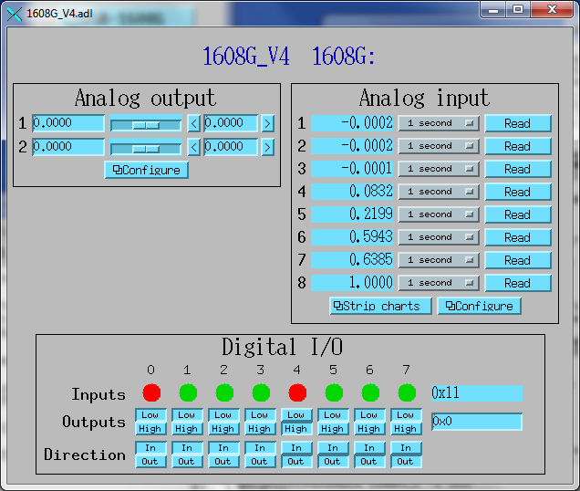

Measurement Computing 1608GX-2A0 Driver

Version 5

* Add pulse generator output and counter inputs
  + 8 new parameters, PULSE_RUN, PULSE_PERIOD, PULSE_WIDTH, PULSE_DELAY, PULSE_COUNT, PULSE_IDLE_STATE, COUNTER_VALUE, COUNTER_RESET
* Counter inputs are polled in poller thread, SCAN=I/O Intr
* 484 lines of code (~170 more than Version 4)

/* drvUSB1608G_V5.cpp

*

* Driver for Measurement Computing USB-1608G multi-function DAQ board using asynPortDriver base class

*

* This version implements digital inputs and outputs, simple analog inputs and simple analog outputs, will a poller thread

*

* Mark Rivers

* April 14, 2012

*/

#include <iocsh.h>

#include <epicsExport.h>

#include <epicsThread.h>

#include <asynPortDriver.h>

#include "cbw.h"

static const char *driverName = "USB1608G";

// Analog output parameters

#define analogOutValueString "ANALOG_OUT_VALUE"

// Analog input parameters

#define analogInValueString "ANALOG_IN_VALUE"

#define analogInRangeString "ANALOG_IN_RANGE"

// Digital I/O parameters

#define digitalDirectionString "DIGITAL_DIRECTION"

#define digitalInputString "DIGITAL_INPUT"

#define digitalOutputString "DIGITAL_OUTPUT"

**// Pulse output parameters**

**#define pulseGenRunString "PULSE_RUN"**

**#define pulseGenPeriodString "PULSE_PERIOD"**

**#define pulseGenWidthString "PULSE_WIDTH"**

**#define pulseGenDelayString "PULSE_DELAY"**

**#define pulseGenCountString "PULSE_COUNT"**

**#define pulseGenIdleStateString "PULSE_IDLE_STATE"**

**// Counter parameters**

**#define counterCountsString "COUNTER_VALUE"**

**#define counterResetString "COUNTER_RESET"**

**#define MIN_FREQUENCY 0.0149**

**#define MAX_FREQUENCY 32e6**

**#define MIN_DELAY 0.**

**#define MAX_DELAY 67.11**

#define NUM_ANALOG_IN 16 // Number analog inputs on 1608G

#define NUM_ANALOG_OUT 2 // Number of analog outputs on 1608G

**#define NUM_COUNTERS 2 // Number of counters on 1608G**

#define NUM_TIMERS 1 // Number of timers on 1608G

#define NUM_IO_BITS 8 // Number of digital I/O bits on 1608G

#define MAX_SIGNALS NUM_ANALOG_IN

#define DEFAULT_POLL_TIME 0.01

/** Class definition for the USB1608G class

*/

class USB1608G : public asynPortDriver {

public:

USB1608G(const char *portName, int boardNum);

/* These are the methods that we override from asynPortDriver */

virtual asynStatus writeInt32(asynUser *pasynUser, epicsInt32 value);

virtual asynStatus readInt32(asynUser *pasynUser, epicsInt32 *value);

virtual asynStatus writeFloat64(asynUser *pasynUser, epicsFloat64 value);

virtual asynStatus getBounds(asynUser *pasynUser, epicsInt32 *low,

epicsInt32 *high);

virtual asynStatus writeUInt32Digital(asynUser *pasynUser, epicsUInt32 value,

epicsUInt32 mask);

virtual void report(FILE *fp, int details);

// These should be private but are called from C

virtual void pollerThread(void);

protected:

**// Pulse generator parameters**

**int pulseGenRun_;**

**#define FIRST_USB1608G_PARAM pulseGenRun_**

**int pulseGenPeriod_;**

**int pulseGenWidth_;**

**int pulseGenDelay_;**

**int pulseGenCount_;**

**int pulseGenIdleState_;**

**// Counter parameters**

**int counterCounts_;**

**int counterReset_;**

// Analog output parameters

int analogOutValue_;

// Analog input parameters

int analogInValue_;

int analogInRange_;

// Digital I/O parameters

int digitalDirection_;

int digitalInput_;

int digitalOutput_;

#define LAST_USB1608G_PARAM digitalOutput_

private:

int boardNum_;

double pollTime_;

int forceCallback_;

**int startPulseGenerator();**

**int stopPulseGenerator();**

**int pulseGenRunning_;**

};

#define NUM_PARAMS (&LAST_USB1608G_PARAM - &FIRST_USB1608G_PARAM + 1)

/** Constructor for the USB1608G class

*/

USB1608G::USB1608G(const char *portName, int boardNum)

: asynPortDriver(portName, MAX_SIGNALS, NUM_PARAMS,

// Interfaces that we implement

asynInt32Mask | **asynFloat64Mask** | asynUInt32DigitalMask | asynDrvUserMask,

// Interfaces that do callbacks

**asynInt32Mask | asynFloat64Mask** | asynUInt32DigitalMask,

/* ASYN_CANBLOCK=1, ASYN_MULTIDEVICE=1, autoConnect=1 */

ASYN_MULTIDEVICE | ASYN_CANBLOCK, 1, 0, 0), /* Default priority and stack size */

boardNum_(boardNum),

pollTime_(DEFAULT_POLL_TIME),

forceCallback_(1)

{

**// Pulse generator parameters**

**createParam(pulseGenRunString, asynParamInt32, &pulseGenRun_);**

**createParam(pulseGenPeriodString, asynParamFloat64, &pulseGenPeriod_);**

**createParam(pulseGenWidthString, asynParamFloat64, &pulseGenWidth_);**

**createParam(pulseGenDelayString, asynParamFloat64, &pulseGenDelay_);**

**createParam(pulseGenCountString, asynParamInt32, &pulseGenCount_);**

**createParam(pulseGenIdleStateString, asynParamInt32, &pulseGenIdleState_);**

**// Counter parameters**

**createParam(counterCountsString, asynParamInt32, &counterCounts_);**

**createParam(counterResetString, asynParamInt32, &counterReset_);**

// Analog output parameters

createParam(analogOutValueString, asynParamInt32, &analogOutValue_);

// Analog input parameters

createParam(analogInValueString, asynParamInt32, &analogInValue_);

createParam(analogInRangeString, asynParamInt32, &analogInRange_);

// Digital I/O parameters

createParam(digitalDirectionString, asynParamUInt32Digital, &digitalDirection_);

createParam(digitalInputString, asynParamUInt32Digital, &digitalInput_);

createParam(digitalOutputString, asynParamUInt32Digital, &digitalOutput_);

/* Start the thread to poll digital inputs and do callbacks to

* device support */

epicsThreadCreate("USB1608GPoller",

epicsThreadPriorityLow,

epicsThreadGetStackSize(epicsThreadStackMedium),

(EPICSTHREADFUNC)pollerThreadC,

this);

}

**int USB1608G::startPulseGenerator()**

**{**

**int status=0;**

**double frequency, period, width, delay;**

**int timerNum=0;**

**double dutyCycle;**

**int count, idleState;**

**static const char *functionName = "startPulseGenerator";**

**getDoubleParam (timerNum, pulseGenPeriod_, &period);**

**getDoubleParam (timerNum, pulseGenWidth_, &width);**

**getDoubleParam (timerNum, pulseGenDelay_, &delay);**

**getIntegerParam(timerNum, pulseGenCount_, &count);**

**getIntegerParam(timerNum, pulseGenIdleState_, &idleState);**

**frequency = 1./period;**

**if (frequency < MIN_FREQUENCY) frequency = MIN_FREQUENCY;**

**if (frequency > MAX_FREQUENCY) frequency = MAX_FREQUENCY;**

**dutyCycle = width * frequency;**

**period = 1. / frequency;**

**if (dutyCycle <= 0.) dutyCycle = .0001;**

**if (dutyCycle >= 1.) dutyCycle = .9999;**

**if (delay < MIN_DELAY) delay = MIN_DELAY;**

**if (delay > MAX_DELAY) delay = MAX_DELAY;**

**status = cbPulseOutStart(boardNum_, timerNum, &frequency, &dutyCycle, count,**

**&delay, idleState, 0);**

**if (status != 0) {**

**asynPrint(pasynUserSelf, ASYN_TRACE_ERROR,**

**"%s:%s: started pulse generator %d period=%f, width=%f, count=%d,**

**delay=%f, idleState=%d, status=%d\n",**

**driverName, functionName, timerNum, period, width, count, delay,**

**idleState, status);**

**return status;**

**}**

**// We may not have gotten the frequency, dutyCycle, and delay we asked for,**

**// set the actual values in the parameter library**

**pulseGenRunning_ = 1;**

**period = 1. / frequency;**

**width = period * dutyCycle;**

**asynPrint(pasynUserSelf, ASYN_TRACE_FLOW,**

**"%s:%s: started pulse generator %d actual frequency=%f, actual period=%f,**

**actual width=%f, actual delay=%f\n",**

**driverName, functionName, timerNum, frequency, period, width, delay);**

**setDoubleParam(timerNum, pulseGenPeriod_, period);**

**setDoubleParam(timerNum, pulseGenWidth_, width);**

**setDoubleParam(timerNum, pulseGenDelay_, delay);**

**return 0;**

**}**

**int USB1608G::stopPulseGenerator()**

**{**

**pulseGenRunning_ = 0;**

**return cbPulseOutStop(boardNum_, 0);**

**}**

asynStatus USB1608G::writeInt32(asynUser *pasynUser, epicsInt32 value)

{

int addr;

int function = pasynUser->reason;

int status=0;

static const char *functionName = "writeInt32";

this->getAddress(pasynUser, &addr);

setIntegerParam(addr, function, value);

**// Pulse generator functions**

**if (function == pulseGenRun_) {**

**// Allow starting a run even if it thinks its running,**

**// since there is no way to know when it got done if Count!=0**

**if (value) {**

**status = startPulseGenerator();**

**}**

**else if (!value && pulseGenRunning_) {**

**status = stopPulseGenerator();**

**}**

**}**

**if ((function == pulseGenCount_) ||**

**(function == pulseGenIdleState_)) {**

**if (pulseGenRunning_) {**

**status = stopPulseGenerator();**

**status |= startPulseGenerator();**

**}**

**}**

**// Counter functions**

**if (function == counterReset_) {**

**// LOADREG0=0, LOADREG1=1, so we use addr**

**status = cbCLoad32(boardNum_, addr, 0);**

**}**

// Analog output functions

if (function == analogOutValue_) {

status = cbAOut(boardNum_, addr, BIP10VOLTS, value);

}

callParamCallbacks(addr);

if (status == 0) {

asynPrint(pasynUser, ASYN_TRACEIO_DRIVER,

"%s:%s, port %s, wrote %d to address %d\n",

driverName, functionName, this->portName, value, addr);

} else {

asynPrint(pasynUser, ASYN_TRACE_ERROR,

"%s:%s, port %s, ERROR writing %d to address %d, status=%d\n",

driverName, functionName, this->portName, value, addr, status);

}

return (status==0) ? asynSuccess : asynError;

}

**asynStatus USB1608G::writeFloat64(asynUser *pasynUser, epicsFloat64 value)**

**{**

**int addr;**

**int function = pasynUser->reason;**

**int status=0;**

**static const char *functionName = "writeFloat64";**

**this->getAddress(pasynUser, &addr);**

**setDoubleParam(addr, function, value);**

**// Pulse generator functions**

**if ((function == pulseGenPeriod_) ||**

**(function == pulseGenWidth_) ||**

**(function == pulseGenDelay_)) {**

**if (pulseGenRunning_) {**

**status = stopPulseGenerator();**

**status |= startPulseGenerator();**

**}**

**}**

**callParamCallbacks(addr);**

**if (status == 0) {**

**asynPrint(pasynUser, ASYN_TRACEIO_DRIVER,**

**"%s:%s, port %s, wrote %d to address %d\n",**

**driverName, functionName, this->portName, value, addr);**

**} else {**

**asynPrint(pasynUser, ASYN_TRACE_ERROR,**

**"%s:%s, port %s, ERROR writing %f to address %d, status=%d\n",**

**driverName, functionName, this->portName, value, addr, status);**

**}**

**return (status==0) ? asynSuccess : asynError;**

**}**

void USB1608G::pollerThread()

{

/* This function runs in a separate thread. It waits for the poll time */

static const char *functionName = "pollerThread";

epicsUInt32 newValue, changedBits, prevInput=0;

unsigned short biVal;;

**unsigned long countVal;**

int i;

int status;

while(1) {

lock();

**// Read the counter inputs**

**for (i=0; i<NUM_COUNTERS; i++) {**

**status = cbCIn32(boardNum_, i, &countVal);**

**if (status)**

**asynPrint(pasynUserSelf, ASYN_TRACE_ERROR,**

**"%s:%s: ERROR calling cbCIn32, status=%d\n",**

**driverName, functionName, status);**

**setIntegerParam(i, counterCounts_, countVal);**

**}**

// Read the digital inputs

status = cbDIn(boardNum_, AUXPORT, &biVal);

if (status)

asynPrint(pasynUserSelf, ASYN_TRACE_ERROR,

"%s:%s: ERROR calling cbDIn, status=%d\n",

driverName, functionName, status);

newValue = biVal;

changedBits = newValue ^ prevInput;

if (forceCallback_ || (changedBits != 0)) {

prevInput = newValue;

forceCallback_ = 0;

setUIntDigitalParam(digitalInput_, newValue, 0xFFFFFFFF);

}

for (i=0; i<MAX_SIGNALS; i++) {

callParamCallbacks(i);

}

unlock();

epicsThreadSleep(pollTime_);

}

}

**measCompPulseGen.template**

**###################################################################**

**# Pulse start/stop #**

**###################################################################**

**record(bo, "$(P)$(R)Run")**

**{**

**field(DTYP, "asynInt32")**

**field(OUT, "@asyn($(PORT),$(ADDR))PULSE_RUN")**

**field(ZNAM, "Stop")**

**field(ZSV, "NO_ALARM")**

**field(ONAM, "Run")**

**field(OSV, "MINOR")**

**}**

**# NOTE: The records for the period and the frequency are a bit**

**# complex because we want to be able to change either ao record**

**# and have the other one update**

**###################################################################**

**# Pulse period #**

**###################################################################**

**record(ao, "$(P)$(R)Period")**

**{**

**field(PINI, "YES")**

**field(DTYP, "asynFloat64")**

**field(OUT, "@asyn($(PORT),$(ADDR))PULSE_PERIOD")**

**field(VAL, "0.001")**

**field(PREC, "$(PREC)")**

**field(FLNK, "$(P)$(R)CalcFrequency")**

**}**

**###################################################################**

**# Calculate frequency based on new period #**

**###################################################################**

**record(calcout, "$(P)$(R)CalcFrequency")**

**{**

**field(INPA, "$(P)$(R)Period")**

**field(CALC, "1/A")**

**field(SDIS, "$(P)$(R)Frequency.PROC")**

**field(DISV, "1")**

**field(OUT, "$(P)$(R)Frequency PP MS")**

**}**

**###################################################################**

**# Pulse frequency #**

**###################################################################**

**record(ao, "$(P)$(R)Frequency")**

**{**

**field(PREC, "$(PREC)")**

**field(FLNK, "$(P)$(R)CalcPeriod PP MS")**

**}**

**###################################################################**

**# Calculate period based on new frequency #**

**###################################################################**

**record(calcout, "$(P)$(R)CalcPeriod")**

**{**

**field(INPA, "$(P)$(R)Frequency")**

**field(CALC, "1/A")**

**field(SDIS, "$(P)$(R)Period.PROC")**

**field(DISV, "1")**

**field(OUT, "$(P)$(R)Period PP MS")**

**}**

**###################################################################**

**# Pulse width #**

**###################################################################**

**record(ao, "$(P)$(R)Width")**

**{**

**field(PINI, "YES")**

**field(DTYP, "asynFloat64")**

**field(OUT, "@asyn($(PORT),$(ADDR))PULSE_WIDTH")**

**field(VAL, "0.0001")**

**field(PREC, "$(PREC)")**

**}**

**###################################################################**

**# Pulse delay #**

**###################################################################**

**record(ao, "$(P)$(R)Delay")**

**{**

**field(PINI, "YES")**

**field(DTYP, "asynFloat64")**

**field(OUT, "@asyn($(PORT),$(ADDR))PULSE_DELAY")**

**field(VAL, "0.")**

**field(PREC, "$(PREC)")**

**}**

**###################################################################**

**# Pulse count #**

**###################################################################**

**record(longout, "$(P)$(R)Count")**

**{**

**field(PINI, "YES")**

**field(DTYP, "asynInt32")**

**field(OUT, "@asyn($(PORT),$(ADDR))PULSE_COUNT")**

**}**

**###################################################################**

**# Pulse idle state #**

**###################################################################**

**record(bo, "$(P)$(R)IdleState")**

**{**

**field(PINI, "YES")**

**field(DTYP, "asynInt32")**

**field(OUT, "@asyn($(PORT),$(ADDR))PULSE_IDLE_STATE")**

**field(ZNAM, "Low")**

**field(ONAM, "High")**

**field(VAL, "0")**

**}**

**1608GCounter.template**

**record(longin, "$(P)$(R)Counts")**

**{**

**field(DTYP, "asynInt32")**

**field(INP, "@asyn($(PORT),$(ADDR))COUNTER_VALUE")**

**field(SCAN, "I/O Intr")**

**}**

**record(bo, "$(P)$(R)Reset")**

**{**

**field(PINI, "YES")**

**field(DTYP, "asynInt32")**

**field(OUT, "@asyn($(PORT),$(ADDR))COUNTER_RESET")**

**field(VAL, "1")**

**}**

**1608G.substitutions_V5**

**file "$(MEASCOMP)/measCompApp/Db/measCompPulseGen.template"**

**{**

**pattern**

**{ P, R, PORT, ADDR, PREC}**

**{ 1608G:, PulseGen1, 1608G_1, 0, 4}**

**}**

**file "$(MEASCOMP)/measCompApp/Db/1608GCounter.template"**

**{**

**pattern**

**{ P, R, PORT, ADDR}**

**{ 1608G:, Counter1, 1608G_1, 0}**

**{ 1608G:, Counter2, 1608G_1, 1}**

**}**

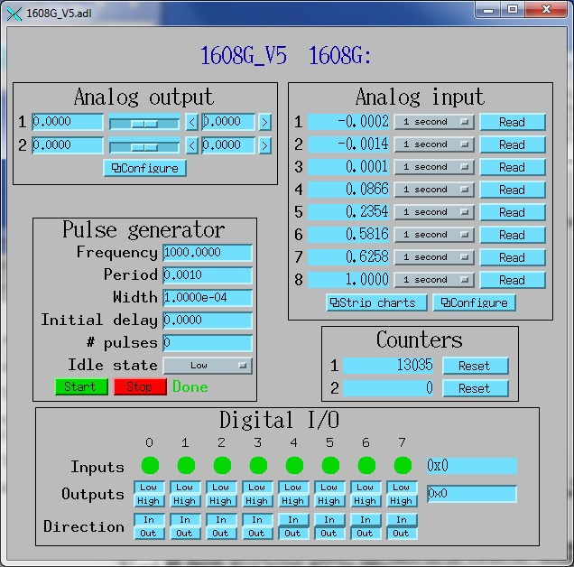

Measurement Computing 1608GX-2A0 Driver

Full Released Version

* Add waveform generator with both predefined and user-defined waveforms
* Add 8-channel waveform digitizer
* Add trigger support
* 42 new parameters
* 1254 lines of code (~770 more than Version 4)
* Supports virtually all features of 1608GX-2A0
* New version written in 2016 has been renamed to drvMultiFunction and supports other Measurement Computing Multifunction devices as well.

