COMPRES III Infrastructure Development Project for a post-doctoral position for the gas-loading system at APS

Mark Rivers
Sergey Tkachev
University of Chicago

The COMPES Infrastructure Development Committee funded the capital equipment costs (~$85,000) of a gas-loading system at the APS. GSECARS contributed the design and construction effort to build the system. The system began operation in February 2008 and has been running with minimal downtime since then. The system works extremely well, with the only significant problems being some failures of the commercial compressor. We have in-house technical support (Guy Macha) to repair such problems, and the mean time to repair has typically been 1 day.

The COMPRES system at the APS is available for use by any member of the COMPRES community, regardless of whether they are performing experiments at GSECARS, at another APS sector, at another synchrotron, or in their home laboratory. The problem for some members of the COMPRES community is that they need to load cells, but cannot afford the time or money to travel to APS.

GSECARS has provided the support (training and supervision) for any users who come to GSECARS to use the system. This is a substantial time commitment for our staff, but one which we can manage with our existing staffing level. We do not, however, have the staff to be able to handle a “mail-in” service to load cells for users; we rely on users to do most of the work once they have been trained. We also do not have the staff to provide assistance to users of other beamlines at the APS, such as the high-pressures users from sectors 3 (inelastic), 4 (magnetism), 16 (HP-CAT), or 32 (imaging).

We propose to continue the COMPRES support for 50% of a post-doc to reside at the APS. This person is responsible for loading cells that are sent to the APS by users who do not travel here, and for assisting users of other APS beamlines with loading their cells. The other part of this person’s salary and responsibilities will be covered by GSECARS.

Dr. Sergey Tkachev began in this post-doc position in the second week of June, 2010. He has performed an excellent job, providing both mail-in service for the COMPRES community not running at the APS, and hands-on assistance for users who come to the APS to load cells when running on any of the beamlines here.

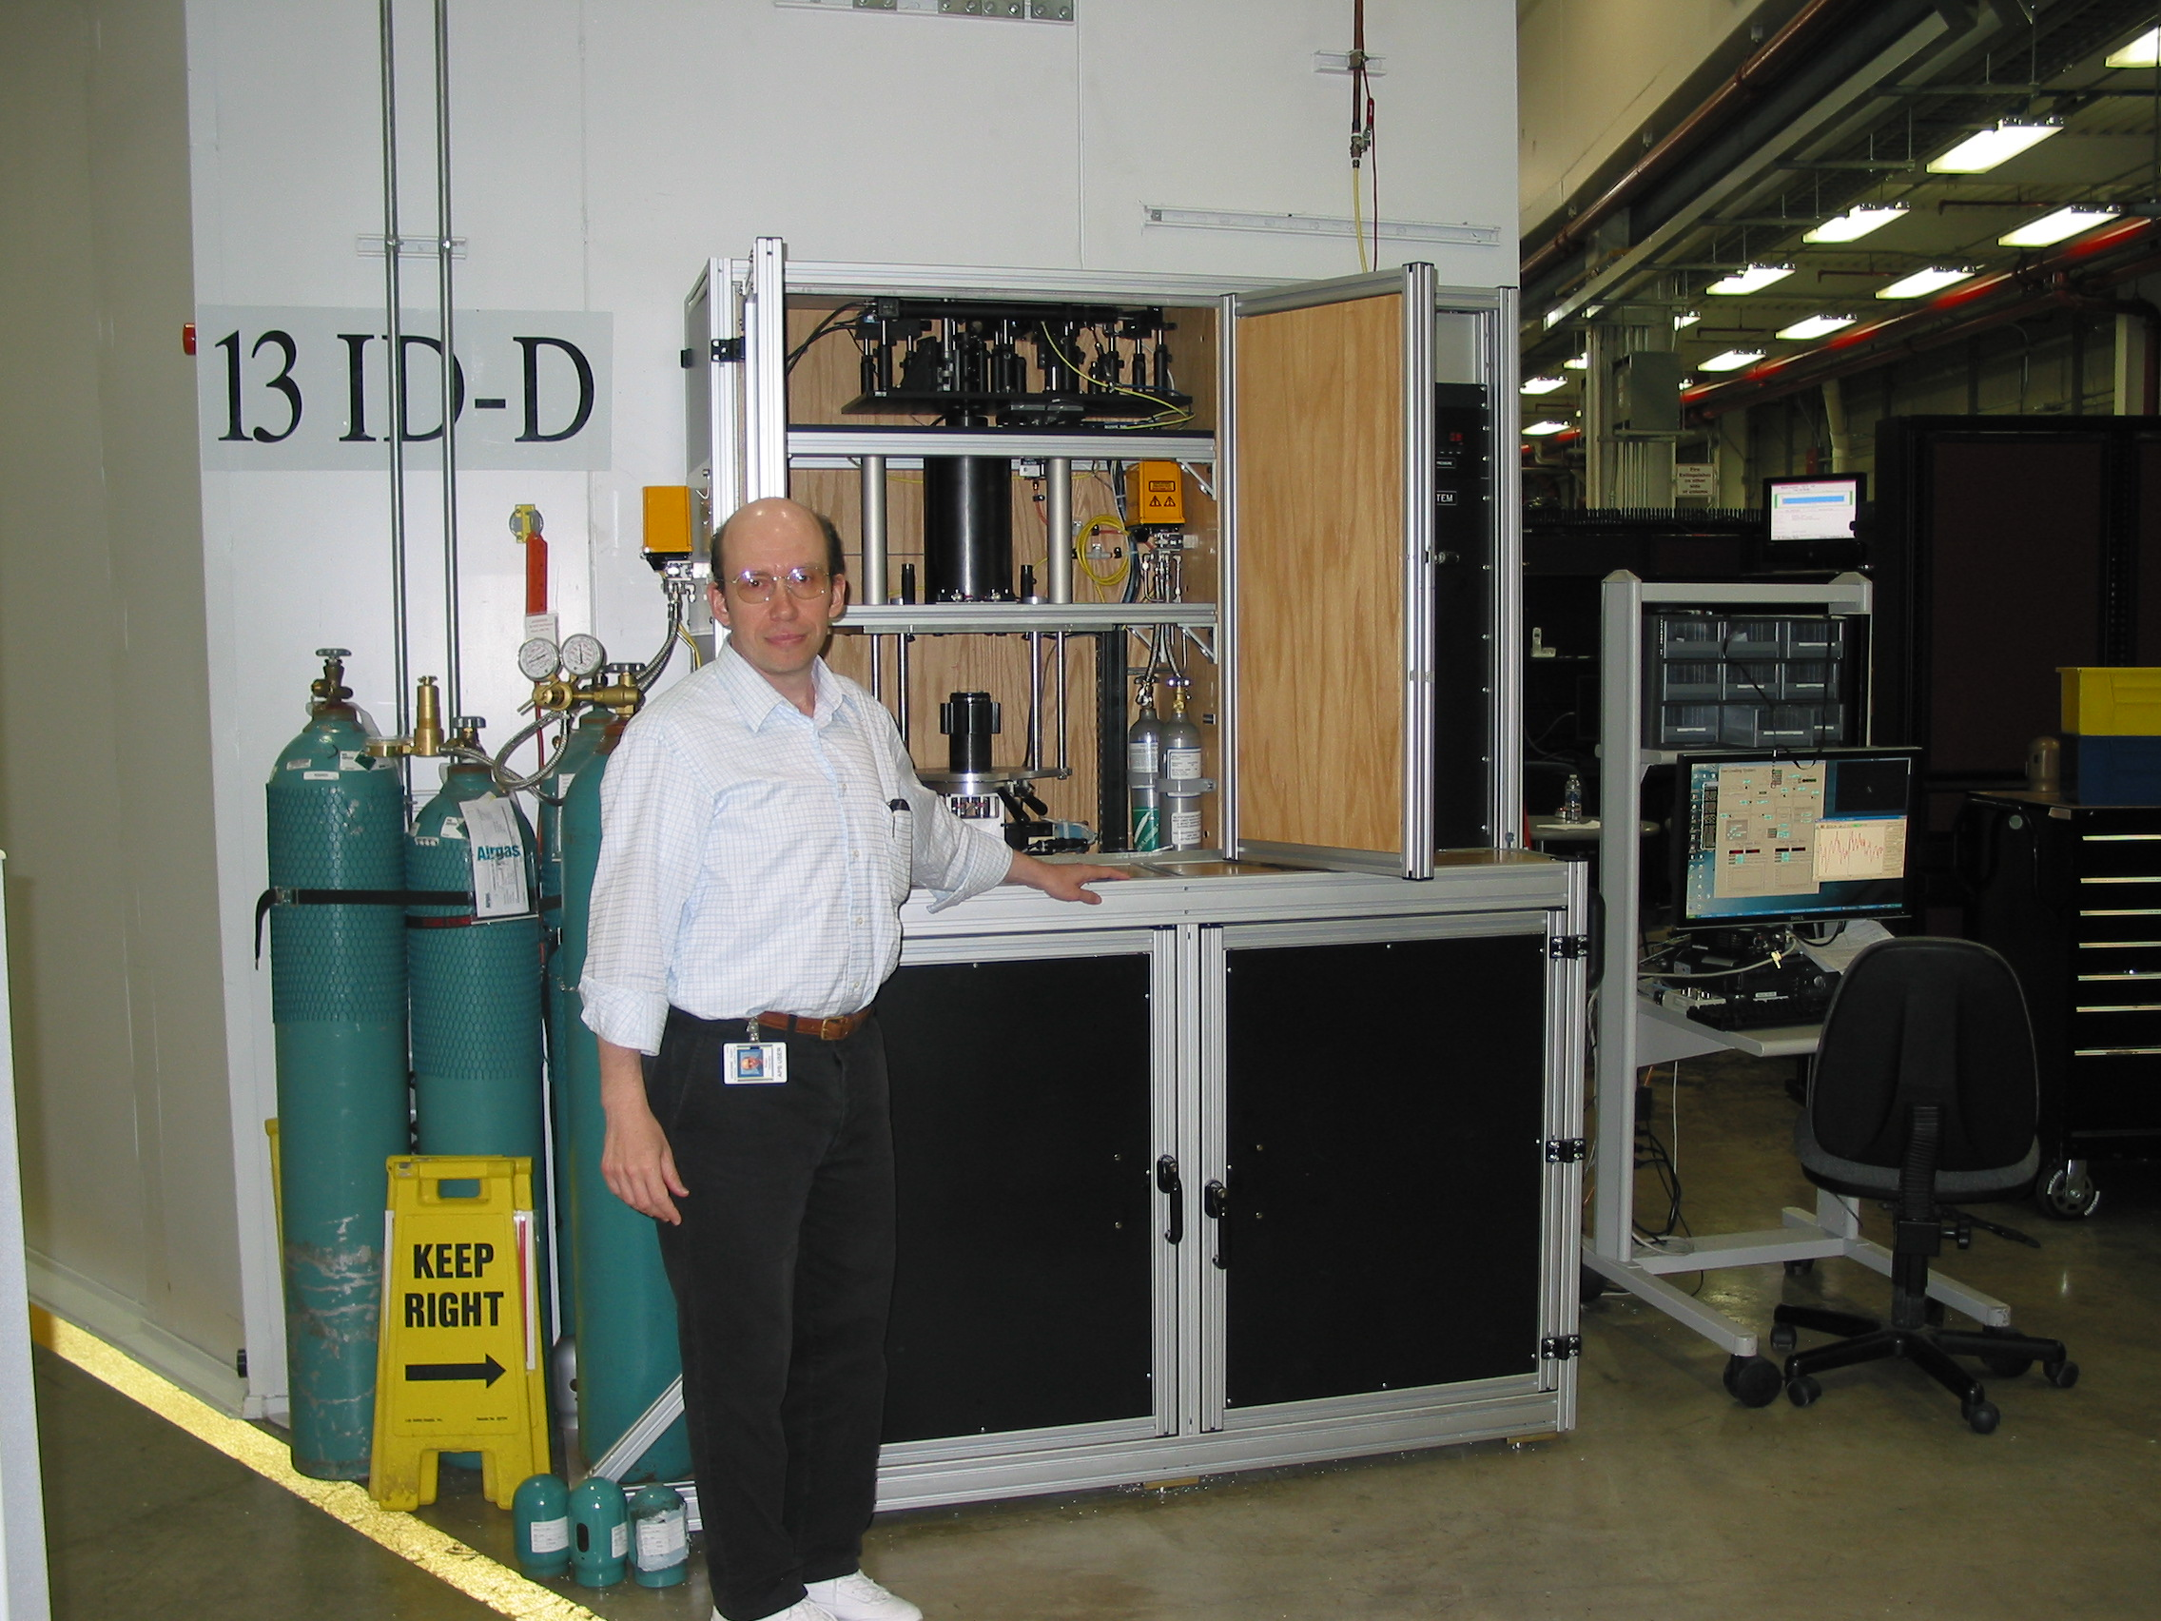
Figure 1. Dr. Sergey Tkachev with the COMPRES/GSECARS gas loading system

The following table summarizes the mail-in service in the current APS run cycle, from February 1, 2011 to April 14, 2011.

University | Name | Number of DACs loaded
UCLA | Miao Xie | 3
UNLV | Barbara Lavian & John Howard | 5
Ohio State University | Daniel Reaman | 4
LBNL | Simon Clark | 2
Caltech | June Wicks | 1
TOTAL |  | 15

A total of 15 diamond-anvil cells have been loaded in this 2.5 month period for 5 user groups with the COMPRES supported mail-in service.

In addition to this mail-in service, there have been 165 users who have loaded cells in this same 2.5 month period. 75 of these users were performing experiments at GSECARS, while the remaining 90 were performing experiments at other APS sectors. 127 of these users were directly assisted by Sergey in loading their cells. Thus on average he is assisting more than 2 users with gas loading every working day. Sergey spends more than 50% of his time assisting such users and doing the mail-in service cells.

The following is a description of the mail-in service, as presented at 2010 COMPRES Annual Meeting:

- Mail-in service is available only for diamond anvil cells (DACs) that are being used for experiments at locations other than the APS.
  - Users who wish to load cells for experiments at the APS, including GSECARS, HPCAT and other APS beamlines, are expected to load the cells themselves.
  - Training and assistance will be provided by the staff from the beamline where the experiment will be conducted.
- Potential users must contact Sergey (tkachev@cars.uchicago.edu, 630-252-0430) to discuss the technical and scheduling requirements prior to sending the cells to the APS.
  - At this time we are providing mail-in service only for Ne and He gases in the standard symmetrical (Princeton) DAC
  - For all other type of DACs and gases the available options should be discussed directly with Sergey.
- Cells must be shipped with appropriate packaging that can also be used to return the cells.
  - A prepaid shipping label must be included for returning the cells to you.
  - Cells containing any hazardous materials must be not be shipped directly to GSECARS, but rather to the hazardous materials receiving building at Argonne.
  - Contact Sergey or Nancy Lazarz (lazarz@cars.aps.anl.gov) for details.
- We will make every effort to load the cells with the requested gas at the desired pressure.
  - However, COMPRES and GSECARS cannot guarantee that the cell will be successfully loaded.
  - The loading process also entails some risk of damaging the cell or diamonds. Users accept this risk, and agree not to hold COMPRES or GSECARS, or any of their staff, liable for any damage that may occur.
- Mail-in service is available only to staff and visitors at COMPRES member institutions in the United States, with shipping to and from US locations only.
Proposed budget

We are asking here for a continuation of the current level of funding for 50% of the post-doc salary.

Budget
Salary for post-doc | $50,000
Fringe (23.5%) | $11,750
Total before indirect | $61,750
Indirect (26%) | $16,055
Total with indirect | $77,805
COMPRES share (50%) | $38,903

