Thoughts and Tributes for Nikolai Sobolev

By Robert Liebermann and Alexander Sobolev.

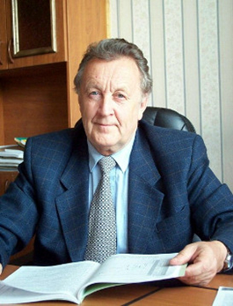

The Siberian Branch of Russian Academy of Sciences (RAS), Joint Scientific Council on Earth Sciences of the Siberian Branch of RAS, V.S. Sobolev Institute of Geology and Mineralogy of the Siberian Branch of RAS announced with the deepest sorrow that on March 25, 2022, Nikolai Vladimirovich Sobolev, an outstanding scientist and expert in the fields of mineralogy, petrology and geochemistry, passed away. The RAS obituary follows.

Nikolai Vladimirovich Sobolev was born on May 28, 1935 in Leningrad. In 1958 he graduated with honors from the geological faculty of the Lviv State University named after I. Franko and worked as a head of the mineralogical museum for a year and a half. On May 25, 1960, he started working in the Institute of Geology and Geophysics Siberian Branch of USSR Academy of Sciences (SB RAS), where he rose from the Junior Researcher to the Director of the Associate Institute of Mineralogy and Petrography SB RAS (1990-2006), and Adviser of RAS. In 1963 he defended his PhD and, in 1971, his Doctor of Science thesis. In 1976 at the age of forty, together with future Academicians N.L. Dobretsov and V.V. Reverdatto, he was awarded the Lenin Prize for the series of monographs "Facies of Metamorphism" under the guidance of Academician V.S. Sobolev. In 1981, Nikolai Vladimirovich Sobolev was elected a Corresponding Member and, in 1990 – a Full Member (Academician) of the USSR Academy of Sciences.

Nikolay Vladimirovich was an outstanding scientist, author and co-author of more than 350 papers in peer-reviewed scientific journals, and of ten monographs. He was at the top of the list of the most cited Russian researchers in Earth sciences. According to the Google Scholar, the works with his participation were cited more than twenty thousand times. For 24 years, N.V.Sobolev was the editor-in-chief of the journal "Geology and Geophysics", and, during this period, the journal had the highest impact factor among geological journals in Russia.

Nikolay Vladimirovich Sobolev was one of the world's leading experts in petrology and mineralogy of deep zones of the lithosphere, ultrahigh-pressure metamorphism, and geology of diamond deposits; as well as the recognized leader in these research fields in Russia. A unique role in his research was the study of natural diamonds and coexisting minerals.

The pioneering research of N.V. Sobolev's in the years of 1969-1971, anticipated the similar research of others by many years and greatly impacted the development of several fields of Earth sciences, including experimental research in the field of high pressures and diamond synthesis. They became the basis for creating a set of principally new mineralogical and geochemical methods of forecasting and prospecting diamond deposits, the high efficiency of which was proved by discovering the Yubileinaya pipe in Yakutia (North of Siberia) and forecasting of the Arkhangelsk diamondiferous province(Northwest Russia). These prognoses were highly awarded by the government. The methods developed by N.V. Sobolev have been used worldwide for many decades.

In the 1980s, under the leadership of N.V. Sobolev, the metamorphic rocks of the Kokchetav massif (Kazakhstan) revealing inclusions of micro diamonds and coesite in zircons, garnets and pyroxenes were studied in detail. Thus, it was proved for the first time that these rocks were subjected to ultrahigh pressures due to their immersion into the mantle, which led to the formation of not only coesite but also diamond.

N.V. Sobolev's works have received broad international recognition. He was elected a member of the European Academy, a foreign member of the National Academy of Sciences of the USA and the National Italian Academy of Sciences, an honorary member of the Russian Mineralogical Society and Fellow of several foreign scientific societies, the vice-president of the International Mineralogical Association (IMA) from 1990 to 1994, and the vice-president of the Russian Mineralogical Society. He was awarded the A.E. Fersman Prize of the Russian Academy of Sciences and the A. von Humboldt International Award

N.V. Sobolev was the first Russian scientist to whom the IMA Council uniting mineralogical societies of about 40 countries, granted the highest award of the IMA - the "Medal of Excellence in Mineralogical Sciences". The last award he received was the Friedrick-Becke-Medaillé of the Austrian Mineralogical Society (2019).

N.V. Sobolev was a laureate of the Lenin and State Prizes of the USSR, an honored scientist of the Yakut ASSR, awarded with many orders and medals. Among the pupils of N.V. Sobolev are two academicians of the Russian Academy of Sciences and about 30 doctors and candidates of sciences.

*Following written by Bob Liebermann*

From 1970 to 1976, I was a member of the research faculty of the Department of Geophysics and Geochemisty [late the Research School of Earth Sciences] of the Australian National University in Canberra. In 1975, Nikolai (Nick) Sobolev, Professor at the Institute of Geology and Mineralogy of the Siberian Branch of the Russian Academy of Sciences in Novosibirsk visited the ANU as a guest of David Brown. While there, he performed high-pressure petrological experiments with David Green in the laboratory of Ted Ringwood. Nick Sobolev is the son of Academician Vladimir Stepanovich Sobolev, who is famous for first predicting the probability of diamonds in Yakutia in northern Siberia. He is one of four Sobolev brothers who are scientists, including three geologists (Nick, Alex and Stefan) and one physicist (Evgeny, who was an expert in the physics of diamond); see figures 2-4 below. During Nick’s stay in Canberra, his father visited and we took him to see the kangaroos at the nearby Tidbinbilla Nature Reserve in the Brindabella Mountain Range. We also took Nick to the Pacific Coast beach at Lillipilli (Fig. 5), but he declined to use sunscreen and thus acquired a severe sunburn (which made it uncomfortable to wear a shirt at a formal dinner at University House that night).

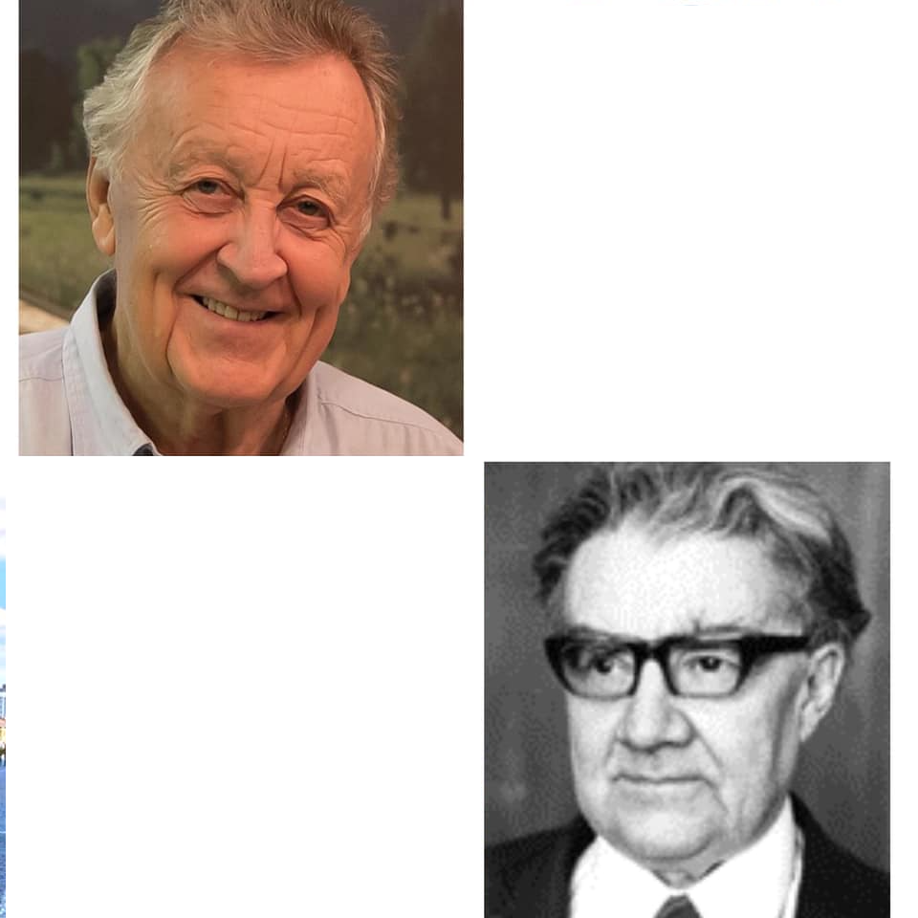

Fig. 2. Nikolai and Vladimir Sobolev

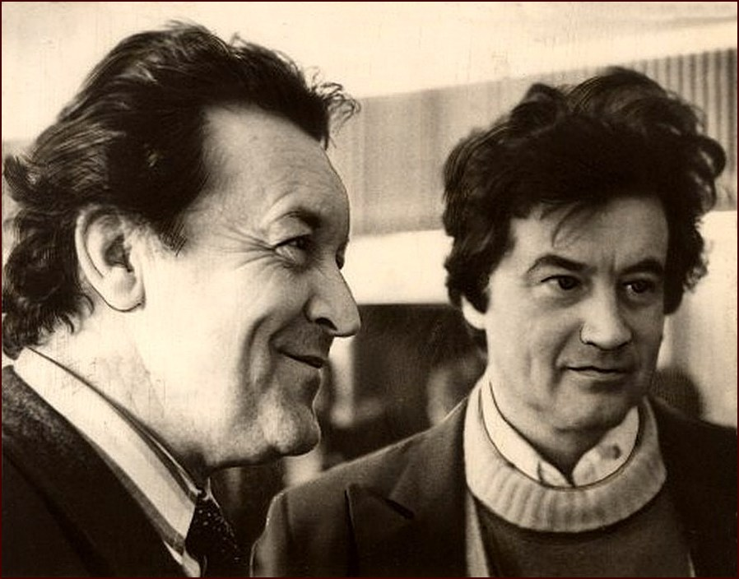

Fig. 3. Nikolai and Evgeny Sobolev



Fig. 4. This photo is called *The Five Sobolevs*: Nick in the center, Stefan on his left, Alexander on his right. Their father is in bronze and on the poster. That was in 2018, at the International Scientific Symposium commemorating the 110 years of Vladimir Sobolev in Novosibirsk in the V.S.Sobolev Institute of Geology and Mineralogy, Siberian Branch of Russian Academy of Sciences.

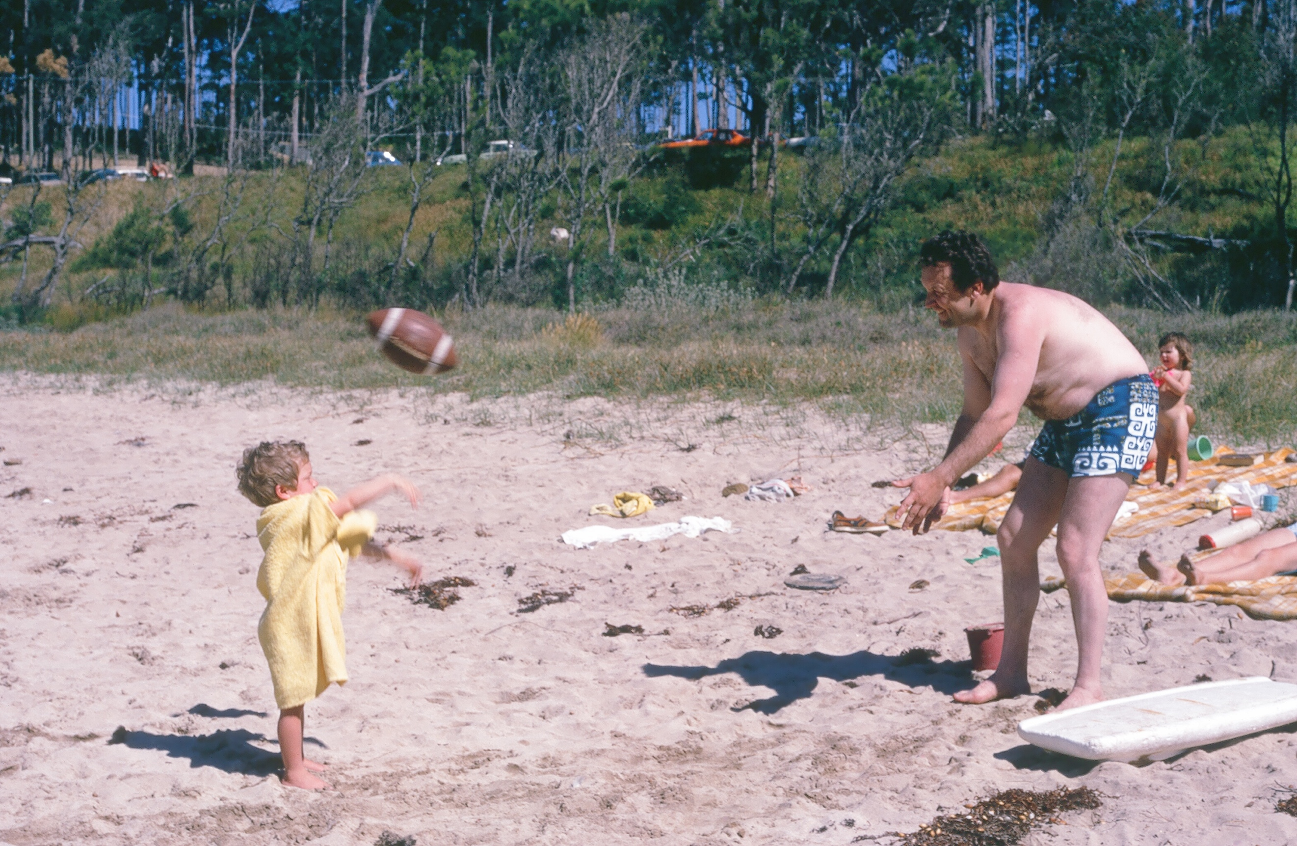

Fig. 5. My daughter Karen Liebermann and Nick Sobolev playing football at Lillipilli Beach in southeastern Australia.

In 1992 after the 9th High-Pressure Mineral Physics Seminar in Verbania, Italy, I visited Nick Sobolev in Novosibirsk and gave an invited talk at an international conference. Yuriy Litvin remembers that in my talk, I said that I was going to speak slowly for Japanese colleagues, which seemed a funny thing to say in front of the Russians. When my return flight to New York was delayed by more than one day due to a strike by Aeroflot, I survived on vodka and watermelon at the airport in Novosibirsk.

In subsequent years, I enjoyed meeting Nick at scientific meetings of the American Geophysical Union and the European Geophysical Union. With many colleagues and friends, I guard many fond memories of Nick as a scientist and person.

* *The International Mineralogical Association presented its 2013 Medal of Excellence in Mineralogical Sciences to Nikolai V. Sobolev. His citation follows.*
* **Nikolai (Nick) Sobolev** was a Professor at the V. S. Sobolev Institute of Geology and Mineralogy of the Siberian Branch of the Russian Academy of Sciences in Novosibirsk, Russia. He followed in the footsteps of his world-famous father, Academician Vladimir Stepanovich Sobolev, who first predicted the probability of diamonds in Yakutia (northern Siberia), as well as his twin brothers (Stefan and Alexander), all 3 geologists. Nick was a Full Member of the Russian Academy of Sciences, a Member of *Academia Europaea* and a Foreign Associate of the U.S. National Academy of Sciences.
* Nick Sobolev was a world-wide distinguished scientist whose work on the petrology, mineralogy, and geochemistry of high-pressure (HP) and ultrahigh-pressure (UHP) crustal and mantle rocks, kimberlites, as well as their xenoliths and diamonds, has had a profound effect on many disciplines in Earth science. He was one of the early pioneers in the study of the morphology and composition of mineral inclusions in diamonds, with a focus on Siberian and Uralian samples, and his 1974 book on “Deep-Seated Inclusions in Kimberlites and the Problem of the Composition of the Upper Mantle” (translated into English by the Geophysical Lab in Washington, D.C. and printed by the American Geophysical Union in 1977) rapidly became not only the world-wide “Bible of Yakutian Kimberlites”, but the most thorough collection and scientific evaluation of mantle mineralogy for decades. Many of the principles in this book were only later recognized for their value in diamond exploration.
* Nick Sobolev first discovered that olivine, pyroxene, garnet, and even native iron inclusions in diamonds are characterized by an imposed octahedral and cubo-octahedral diamond morphology, indicating that the inclusions formed simultaneously with the host diamonds – termed syngenetic. At the end of the 1960s and early 70s, he recognized the importance of inclusions of Cr-rich calcic and subcalcic garnets, as well as Cr-spinels, in diamonds and diamondiferous eclogites/peridotites for the genesis of diamonds; this led to the classification of mantle peridotites into lherzolites, wehrlites, harzburgites, and dunites. This provided the foundation for the current use of mineral compositions in diamond exploration and the estimation of diamond grades. These new mineralogical signature methods have been widely used in diamond exploration since the early 1970s. Indeed, the application by Sobolev and his colleagues of “mineralogical mapping techniques” has been highly successful for the Yakutian kimberlite fields, especially for the discovery of the Yubileynaya diamond mine, and contributed significantly to the discovery of the Arkhangelsk kimberlite province.
* In 1976, Nick Sobolev was the first to discover the full coesite-eclogite assemblage (garnet + omphacite + coesite) in a set of mineral inclusions in Siberian diamonds. He also found an unusual enrichment of diamond-facies environments in eclogites beneath the Guayana shield (Venezuela), Argyle (Australia), and possible sources for diamond placers in the northeastern Siberian Platform and in New South Wales, Australia.
* Nick Sobolev was the first to point out that diamond-bearing mantle could be inferred from significant amounts of sodium and potassium in garnet and clinopyroxene solid solutions, respectively, contained in diamonds, a signature only later picked up by others. On the basis of carbon isotope analyses of diamonds obtained with colleagues in the 1970s, Sobolev first proposed that eclogitic diamonds form from crustal carbon recycled into the mantle by subduction, and that the more abundant peridotitic diamonds formed from mantle carbon. Sobolev’s study of numerous xenoliths of diamondiferous eclogites led to the conclusion that diamond generally formed via a multi-stage process in no way linked to the formation of their host eclogites.
* During the late 1980s, Nick Sobolev began an extensive study of continental eclogites in Kazakhstan. In 1990, together with V. Shatsky, he definitively proved that these rocks contained micro-diamonds. This discovery established “ultrahigh-pressure metamorphism“ (i.e., UHPM) as an entirely new field of research, confirmed by subsequent finds of similar diamondiferous eclogite terranes in Sulu/Dabie Shan, China, in Germany, in Norway, etc. The major significance of these UHP metamorphic terranes was that a major rethinking of the tectonics associated with the subduction and exhumation of oceanic and even continental crust became necessary. Further studies of the Kazakhstan locality led to important contributions on mantle metasomatic processes, in particular the role of volatiles and especially ultrapotassic fluids in diamond formation, and the significance of recycling of crustal rocks.
* Nick Sobolev discovered a diamond with 53 garnet inclusions in 1998, each with different compositions that virtually span the entire range for eclogitic garnets in all of Yakutia. This find seriously addressed and questioned the then-established principle of using garnet and pyroxene inclusions from hundreds of diamonds to date the age of diamond formation.
* Nick Sobolev has written several hundred peer-reviewed scientific papers on mantle mineralogy and petrology as revealed in diamonds and their mineral inclusions. He was the world’s expert in this field, and his name is synonymous with diamond inclusion research. About 20 of his publications have become classics with 100-600 citations each. As shown by the database of Thomson Reuters ISI and Google Scholar Citation, his h-index (48) and more than 8000 total citations are the highest for a Russian Earth scientist.