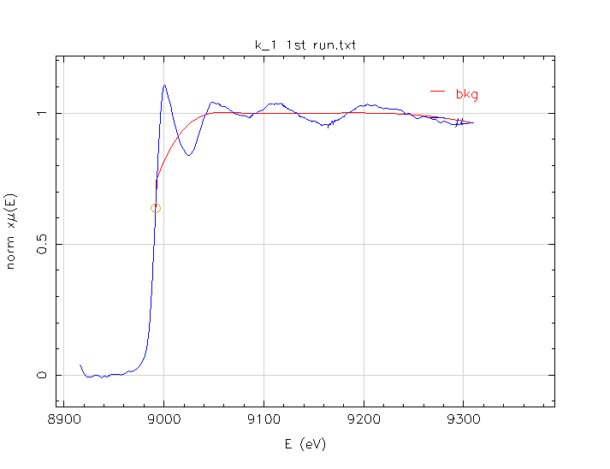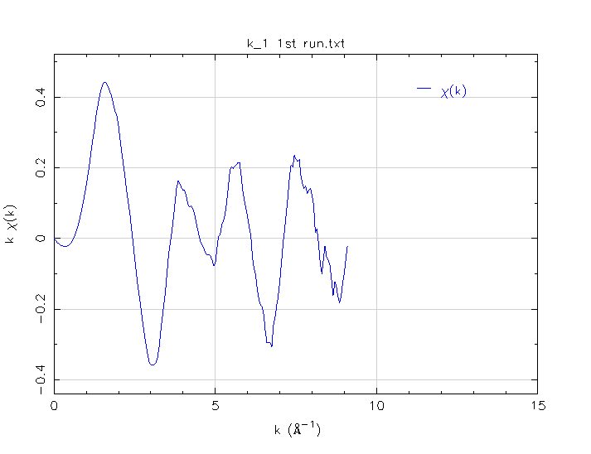

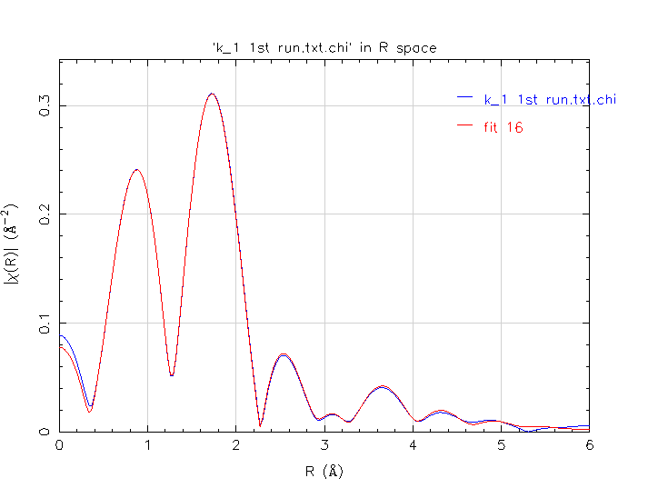 Ind ependent points = 24.263671875
Number of variables = 14.000000000
Chi-square = 96.615058327
Reduced Chi-square = 9.413303495
R-factor = 0.001600761
Measurement uncertainty (k) = 0.001449697
Measurement uncertainty (R) = 0.001410261
Number of data sets = 1.000000000

Guess parameters +/- uncertainties (initial guess):
amp = 1.2954900 +/- 0.0752760 (1.0000)
enot = -5.1405240 +/- 0.4778700 (0.0000)
delr = -0.0756230 +/- 0.0071860 (0.0000)
ss = -0.0336280 +/- 0.0021190 (0.0030)
delr1 = -0.3317980 +/- 0.0064630 (0.0000)
delr2 = 0.1084810 +/- 0.0066720 (0.0000)
delr3 = -0.0663690 +/- 0.0575630 (0.0000)
delr4 = -0.1425410 +/- 0.0530520 (0.0000)
ss1 = -0.0254000 +/- 0.0018090 (0.0030)
ss2 = -0.0346350 +/- 0.0019650 (0.0030)
ss3 = -0.0150530 +/- 0.0212050 (0.0030)
ss4 = -0.0186490 +/- 0.0070250 (0.0030)
delr5 = -0.0545260 +/- 0.1120010 (0.0000)
ss5 = -0.0061850 +/- 0.0217690 (0.0030)

