NOTES ON EXAFS SIMULATIONS:

1. Shift in the k space to lower k value
Dear FEFF user, here two spectra Cu010k (experimental) and xmu29 (simulation) are represented. Cu010k is the name of the Cu foil spectrum collected at 10K by M. Newville (you can find it on Athena examples).
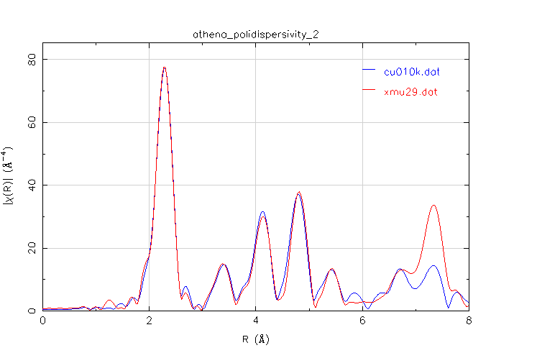
Figure 1: 3 <k<18, dk=1 Å-1.
The simulated spectrum looks ok but it does not look “perfect” above all between 4 and 5Å. The peaks between 6<R<8 Å are all due to multiple scattering contributions, so a mismatch between experimental data and simulations might be expected (EXAFS simulations are not the best to simulate MS). FEFF8.4 is used.
This problem, a small shift to lower k, is easy to see on k space
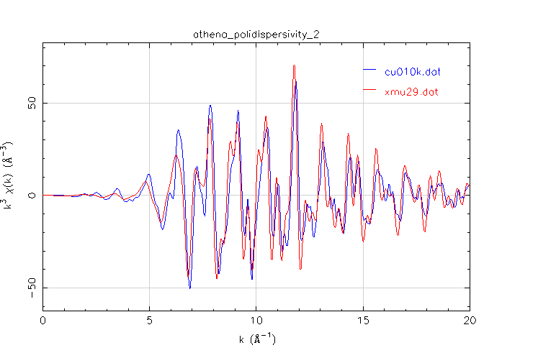
Figure 2: Experimental (cu010k) and simulated (xmu29) EXAFS spectra

There is small shift to low k value; is it significant shift? How to solve this problem?

I tried to correct it playing with the cards MULTIPLIER, EXCHANGE (Hedin-Lundqvist potential always used) and CORRECTION without success.
Here below there is the almost-complete feff.inp and followed by some graphs to explain you why I used a large ‘vicorr’ on CORRECTION. A new simulation (xmu31) is used to in the following pages.

Feff.inp xmu 29: (the feff.inp of xmu.31 is equal to xmu29 with the only difference of CORRECTION card)
TITLE xmu29
CONTROL 1 1 1 1 1 1

PRINT 0 0 0 0 0 0

RMULTIPLIER 1

LDOS -30 20 0.2
EDGE K
S02 1.0

SCF 4 0 30 0.2 1
NLEG 5
EXCHANGE 0 0 0 0
DEBYE 10 343 0
EXAFS
CORRECTIONS 0 3 ==➔ for the simulation xmu.31 CORRECTIONS 0 0
RPATH 10.0
POTENTIALS
0 29 Cu 3 3 0.0010
1 29 Cu 3 3 1.0
Atoms
ATOMS
0.00000 0.00000 0.00000 0 Cu 0.00000
1.80753 1.80753 0.00000 1 Cu_1 2.55623
-1.80753 1.80753 0.00000 1 Cu_1 2.55623
1.80753 -1.80753 0.00000 1 Cu_1 2.55623
-1.80753 -1.80753 0.00000 1 Cu_1 2.55623
1.80753 0.00000 1.80753 1 Cu_1 2.55623
-1.80753 0.00000 1.80753 1 Cu_1 2.55623
0.00000 1.80753 1.80753 1 Cu_1 2.55623
0.00000 -1.80753 1.80753 1 Cu_1 2.55623
1.80753 0.00000 -1.80753 1 Cu_1 2.55623
-1.80753 0.00000 -1.80753 1 Cu_1 2.55623
0.00000 1.80753 -1.80753 1 Cu_1 2.55623
0.00000 -1.80753 -1.80753 1 Cu_1 2.55623
3.61505 0.00000 0.00000 1 Cu_2 3.61505
-3.61505 0.00000 0.00000 1 Cu_2 3.61505
0.00000 3.61505 0.00000 1 Cu_2 3.61505
0.00000 -3.61505 0.00000 1 Cu_2 3.61505
0.00000 0.00000 3.61505 1 Cu_2 3.61505
0.00000 0.00000 -3.61505 1 Cu_2 3.61505
3.61505 1.80753 1.80753 1 Cu_3 4.42752
-3.61505 1.80753 1.80753 1 Cu_3 4.42752
1.80753 3.61505 1.80753 1 Cu_3 4.42752
-1.80753 3.61505 1.80753 1 Cu_3 4.42752
3.61505 -1.80753 1.80753 1 Cu_3 4.42752
-3.61505 -1.80753 1.80753 1 Cu_3 4.42752
1.80753 -3.61505 1.80753 1 Cu_3 4.42752
-1.80753 -3.61505 1.80753 1 Cu_3 4.42752
1.80753 1.80753 3.61505 1 Cu_3 4.42752
-1.80753 1.80753 3.61505 1 Cu_3 4.42752
1.80753 -1.80753 3.61505 1 Cu_3 4.42752
-1.80753 -1.80753 3.61505 1 Cu_3 4.42752
3.61505 1.80753 -1.80753 1 Cu_3 4.42752
-3.61505 1.80753 -1.80753 1 Cu_3 4.42752
1.80753 3.61505 -1.80753 1 Cu_3 4.42752
-1.80753 3.61505 -1.80753 1 Cu_3 4.42752
3.61505 -1.80753 -1.80753 1 Cu_3 4.42752
-3.61505 -1.80753 -1.80753 1 Cu_3 4.42752
1.80753 -3.61505 -1.80753 1 Cu_3 4.42752
-1.80753 -3.61505 -1.80753 1 Cu_3 4.42752
1.80753 1.80753 -3.61505 1 Cu_3 4.42752
-1.80753 1.80753 -3.61505 1 Cu_3 4.42752
1.80753 -1.80753 -3.61505 1 Cu_3 4.42752
-1.80753 -1.80753 -3.61505 1 Cu_3 4.42752
3.61505 3.61505 0.00000 1 Cu_4 5.11245
-3.61505 3.61505 0.00000 1 Cu_4 5.11245
3.61505 -3.61505 0.00000 1 Cu_4 5.11245
-3.61505 -3.61505 0.00000 1 Cu_4 5.11245
3.61505 0.00000 3.61505 1 Cu_4 5.11245
-3.61505 0.00000 3.61505 1 Cu_4 5.11245
0.00000 3.61505 3.61505 1 Cu_4 5.11245
0.00000 -3.61505 3.61505 1 Cu_4 5.11245
3.61505 0.00000 -3.61505 1 Cu_4 5.11245
-3.61505 0.00000 -3.61505 1 Cu_4 5.11245
0.00000 3.61505 -3.61505 1 Cu_4 5.11245
0.00000 -3.61505 -3.61505 1 Cu_4 5.11245
5.42258 1.80753 0.00000 1 Cu_5 5.71590
-5.42258 1.80753 0.00000 1 Cu_5 5.71590
1.80753 5.42258 0.00000 1 Cu_5 5.71590
-1.80753 5.42258 0.00000 1 Cu_5 5.71590
5.42258 -1.80753 0.00000 1 Cu_5 5.71590
-5.42258 -1.80753 0.00000 1 Cu_5 5.71590
1.80753 -5.42258 0.00000 1 Cu_5 5.71590
-1.80753 -5.42258 0.00000 1 Cu_5 5.71590
5.42258 0.00000 1.80753 1 Cu_5 5.71590
-5.42258 0.00000 1.80753 1 Cu_5 5.71590
0.00000 5.42258 1.80753 1 Cu_5 5.71590
0.00000 -5.42258 1.80753 1 Cu_5 5.71590
1.80753 0.00000 5.42258 1 Cu_5 5.71590
-1.80753 0.00000 5.42258 1 Cu_5 5.71590
0.00000 1.80753 5.42258 1 Cu_5 5.71590
0.00000 -1.80753 5.42258 1 Cu_5 5.71590
5.42258 0.00000 -1.80753 1 Cu_5 5.71590
-5.42258 0.00000 -1.80753 1 Cu_5 5.71590
0.00000 5.42258 -1.80753 1 Cu_5 5.71590
0.00000 -5.42258 -1.80753 1 Cu_5 5.71590
1.80753 0.00000 -5.42258 1 Cu_5 5.71590
-1.80753 0.00000 -5.42258 1 Cu_5 5.71590
0.00000 1.80753 -5.42258 1 Cu_5 5.71590
0.00000 -1.80753 -5.42258 1 Cu_5 5.71590

END
(the original feff.inp was up to 12Å…)

This shift is independent from the large value used for the card CORRECTION 0 3. This can be seen in the next graphs:
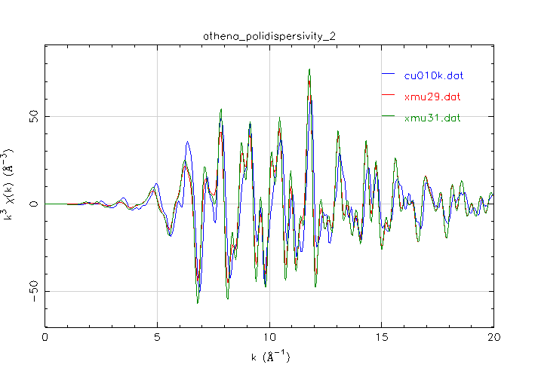
Figure 3: xmu31 and xmu29, differs only for the value of CORRECTION card: in xmu31 correction is 0 0, while for xmu29 is CORRECTION 0 3.

In Fig 4 the FT xmu29, xmu31 and cu010k are represented. Both simulations are scaled to fit the first peak of the experimental FT (Edge step xmu29 = 0.96; Edge step xmu31 = 1.2).
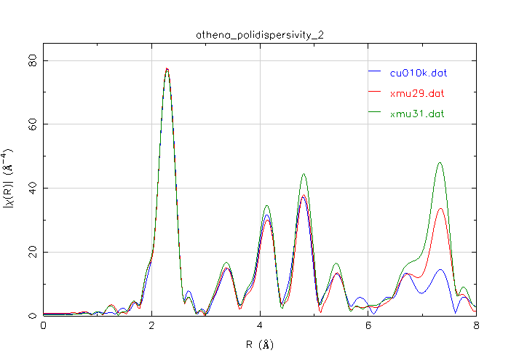
Figure 4: A large value of vicorr is used in xmu29.

